目录
Exterior: 2
Main interface: 3
ignition: 3
sensor: 5
Actuator: 6
bus: 7
Auto repair kit: 8
Load test: 9
Oscilloscope: 10
Channel 1: 11
TRIG: 12
HORI 13
Ruler: 13
MENU 14
Factory reset and self-calibration: 15
Parameter display: 15
multimeter: 16
Set up: 17
Smart trigger: 17
Screenshot preview: 17
Waveform browsing: 18
Parameter Description: 19

Exterior:
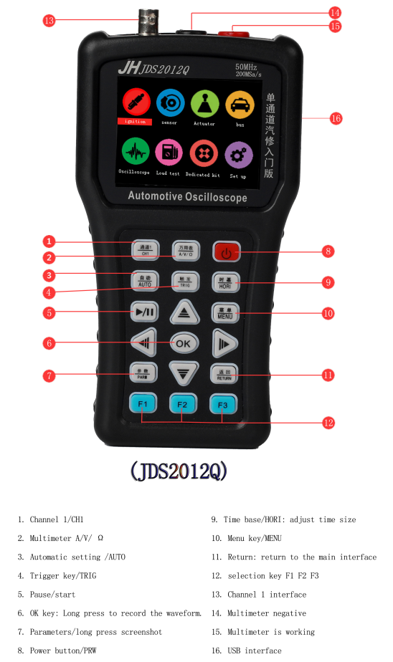

Main interface:
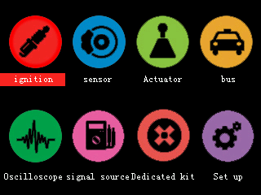

Boot into the main interface, you can use different functions through each submenu.

ignition:
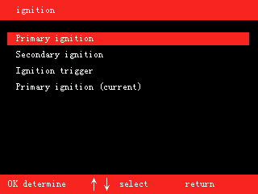
The main function of the ignition menu is to help customers quickly set the commonly used ignition signal parameters of the oscilloscope.
Button function under ignition menu:
OK determine
↑↓ Select function
return Return to the previous menu

Routine1:
Select the primary ignition, after the OK button is confirmed, there will be corresponding notices:
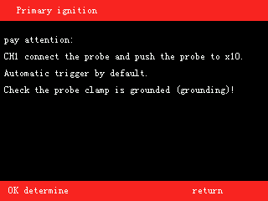

At this time, press the OK key again to enter the waveform test (you can also press the return key to return to the previous menu)
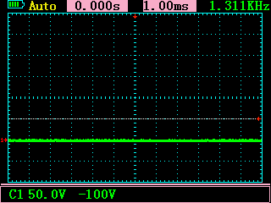
Routine 2 (use of current clamp):
Select primary ignition (current), OK key to confirm after entering the oscilloscope:
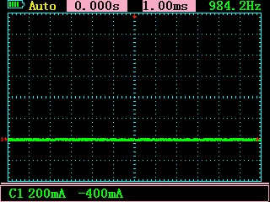
Note: At this time, the relevant parameter values of the oscilloscope interface have been adjusted to the current unit A, and all current parameters can be read directly.

sensor:
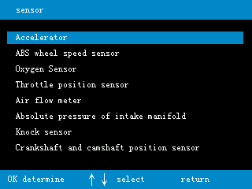
The main function of the sensor menu is to help customers quickly set the commonly used sensor signal parameters of the oscilloscope.
Button function under sensor menu:
OK determine
↑↓ Select function
return Return to the previous menu

Routine:
Select the sliding resistance type of the accelerator pedal, after the OK button is confirmed, there will be corresponding notices:
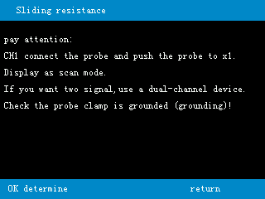
Note: This is a single-channel device, and the accelerator pedal is a two-wire output. To observe the two-wire, you need to use 2022Q.
At this time, press the OK key again to enter the waveform test (you can also press the return key to return to the previous menu)
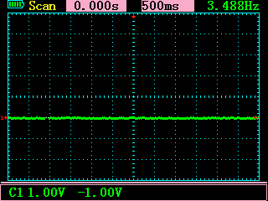

Actuator:
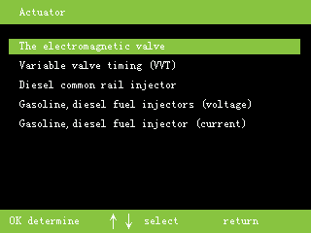
The main function of the actuator menu is to help customers quickly set the commonly used actuator signal parameters of the oscilloscope.
Button function under the actuator menu:
OK determine
↑↓ Select function
Return Return to the previous menu

Routine:
Select the solenoid valve, after the OK button is confirmed, there will be corresponding notices:
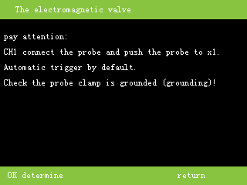
At this time, press the OK key again to enter the waveform test (you can also press the return key to return to the previous menu)

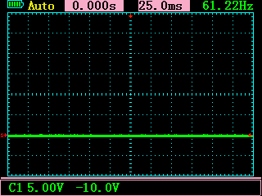

bus:
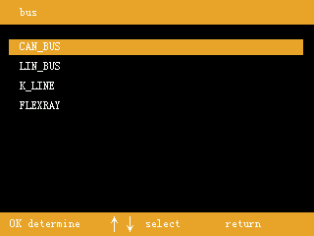
The main function of the bus menu is to help customers quickly set the commonly used bus signal parameters of the oscilloscope.
Button function under bus menu:
OK determine
↑↓ Select function
return Return to the previous menu

Routine:
After selecting the can bus and OK button to confirm, there will be corresponding notices:
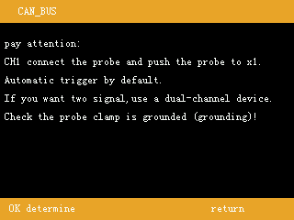
Note: This is a single-channel device, and the accelerator pedal is a two-wire output. To observe the two-wire, you need to use 2022Q.
At this time, press the OK key again to enter the waveform test (you can also press the return key to return to the previous menu)
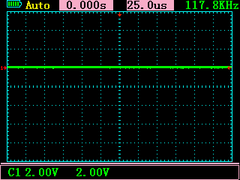

Auto repair kit:
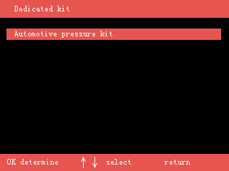
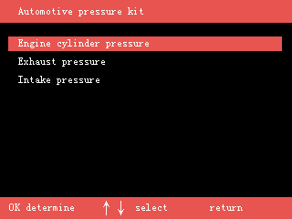
The main function of the car kit menu is to help customers quickly set the relevant parameters of the oscilloscope when using the specified accessories.
Button functions under the car kit menu:
OK determine
↑↓ Select function
return Return to the previous menu

Routine:
Select the engine cylinder pressure and confirm with the OK button, there will be corresponding notices:
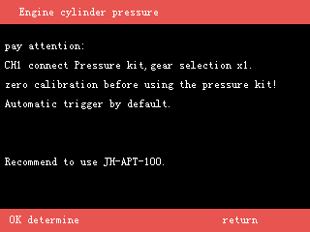
At this time, press the OK key again to enter the waveform test (you can also press the return key to return to the previous menu)
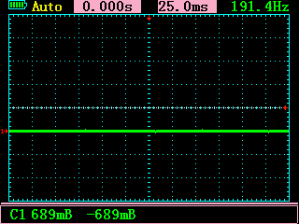
Note: At this time, the relevant parameter values of the oscilloscope interface have been adjusted to the pressure unit Bar, and all pressure parameters can be directly read.

Load test:
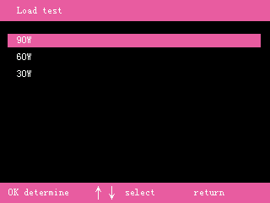
Car load test is mainly to test the car circuit, whether the power supply is sufficient under the condition of heavy load.
Check whether the power supply of the car circuit is normal.
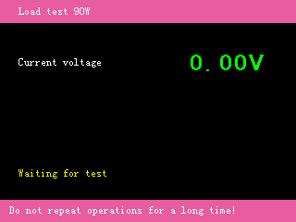
Use the multimeter pen to carry the positive and negative ends of the power cord.
If the power supply meets the current responsible demand, the buzzer will beep for a long time and the green text will be displayed at the same time.
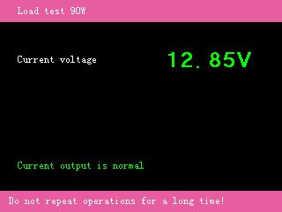
If the power supply cannot meet the current demand, the buzzer will alarm and flash red letters.
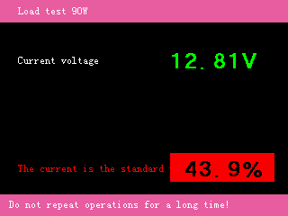

Oscilloscope:
After selecting the oscilloscope in the main menu, you will enter the custom oscilloscope interface.
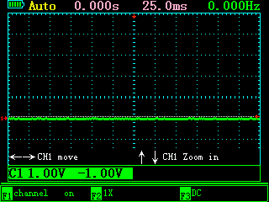
The function buttons of the oscilloscope are classified as follows:

Channel 1:
Press the channel 1 button to enter the channel menu.
Under the channel 1 button, the function keys have the following functions:
F1 Channel 1 display switch
F2 Unit number x1, x10, x100 selection
F3 AC/DC coupling options
OK Save reference waveform when reference waveform A and B are open
← CH1 mobile
→ CH1 mobile
↑ CH1 Gear adjustment
↓ CH1 Gear adjustment

Press the channel 1 button again to enter the channel unit display menu:
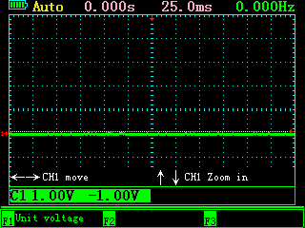
Under the channel 1 button, the function keys have the following functions:
F1 Channel 1 unit selection (voltage, current, pressure)
F2 invalid
F3 invalid
OK Save reference waveform when reference waveform A and B are open
← CH1 mobile
→ CH1 mobile
↑ CH1 Gear adjustment
↓ CH1 Gear adjustment

TRIG:
Press the TRIG-MATH key for the first time to enter the trigger menu.
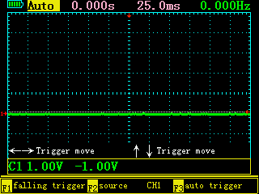
Under the trigger menu, the function keys have the following functions:
F1 Rising edge and falling edge trigger selection
F2 Select triggerCH1
F3 Select automatic trigger, normal trigger or single trigger
OK Save reference waveform when reference waveform A and B are open
← Trigger movement (when smart trigger is off)
→ Trigger movement (when smart trigger is off)
↑ invalid
↓ invalid

HORI
Press the time base key to enter the following menu:
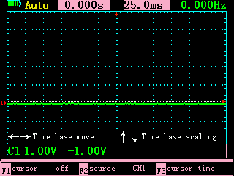
Under the time base menu, the function keys have the following functions:
F1 Whether the ruler is displayed
F2 The object of the ruler isCH1
F3 The unit of the ruler (time, voltage or current or pressure)
OK Save reference waveform when reference waveform A and B are open
← Trigger reference point movement
→ Trigger reference point movement
↑ Time base adjustment
↓ Time base adjustment

Ruler:
In the time base menu, choose to open the cursor, and you will enter the ruler menu:
The upper foot of the interface will display the parameters of scale 1, 2
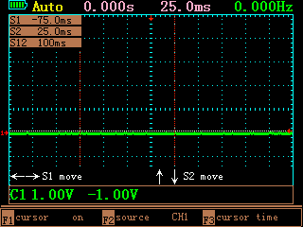
Under the time base menu, the function keys have the following functions:
F1 Whether the ruler is displayed
F2 The object of the ruler isCH1
F3 The unit of the ruler (time, voltage or current or pressure)
OK Save reference waveform when reference waveform A and B are open
← Ruler 1 moves
→ Ruler 1 moves
↑ Ruler 2 moves
↓ Ruler 2 moves

MENU
Press the menu key for the first time to enter the following interface.
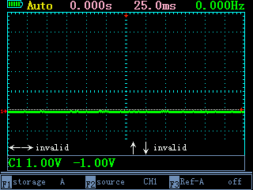
Under the menu, the function key functions are as follows:
F1 Reference waveform A or B
F2 Reference waveform saveCH1
F3 Whether reference waveform A or B is open
OK Save reference waveform when reference waveform A and B are open
← invalid
→ invalid
↑ invalid
↓ invalid

Press the menu button for the second time to enter the following interface.
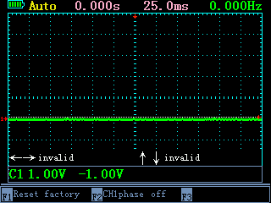
Under the menu, the function key functions are as follows:
F1 Enter the factory reset menu
F2 CH1 Whether the waveform is inverted
F3 invalid
OK Save reference waveform when reference waveform A and B are open
← invalid
→ invalid
↑ invalid
↓ invalid

Factory reset and self-calibration:
Select factory reset in the menu and enter the following menu.
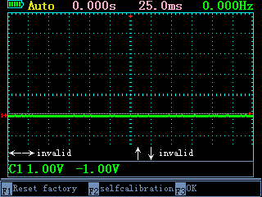
Under the menu, the function key functions are as follows:
F1 invalid
F2 Self-calibration
F3 Confirm factory reset
OK Save reference waveform when reference waveform A and B are open
← invalid
→ invalid
↑ invalid
↓ invalid
(Note: Do not connect to any external equipment during self-calibration to ensure that the channel is disconnected!)

Parameter display:
Press the parameter key, the parameters of each channel will be displayed in the upper right corner of the screen:
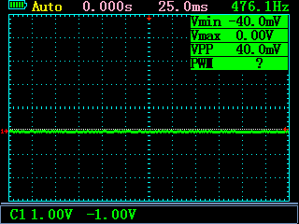
Vmin Minimum voltage (will be displayed as the unit of the relevant channel changes, current, pressure)
Vmax Maximum voltage (will be displayed as the unit of the relevant channel changes, current, pressure)
VPP Amplitude value (will be displayed as the unit of the relevant channel changes, current, pressure)
PWM Duty cycle

multimeter:
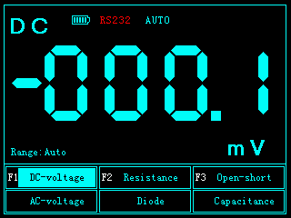
F1 Select DC voltage or AC voltage
F2 Choose resistor or diode
F3 Choose on-off or capacitance
← invalid
→ invalid
↑ invalid
↓ invalid

Set up:
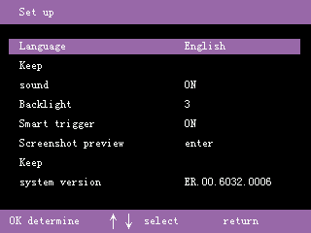
Setting options description:
Language Currently supports 5 languages (Chinese, English, Russian, Spanish, Portuguese)
sound Choose to turn on or off the key sound
Backlight Screen brightness adjustment 1-5 levels
Smart trigger Turn smart trigger on or off
Screenshot preview View the previous screenshot locally
Waveform browsing View the previously saved waveform locally

Smart trigger:
When the smart trigger is turned on, in the oscilloscope, when the waveform meets the trigger condition, the trigger arrow will automatically find the appropriate trigger point and trigger. It saves the manual adjustment step.
This function is only valid in automatic trigger mode, normal trigger and single trigger do not support this function!

Screenshot preview:
This device supports one-click capture of the current screen.
Press and hold the parameter key for 2 seconds, you will hear 2 beeps, and the screenshot will start in the background. After the screenshot is completed, a dialog box for customizing the screenshot number will pop up.
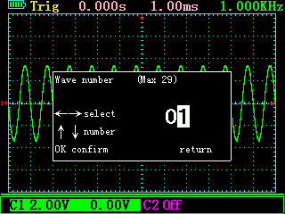
After editing the number (currently supports 0-7 up to 8 pictures), press ok to save.
After the screenshot is completed, select the screenshot preview in the settings, and enter to see the current screenshot.
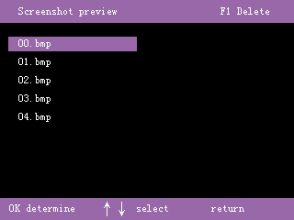
In this interface, you can use the ok key to view the screenshots locally, or use the F1 key to delete the pictures.

Waveform browsing:
In oscilloscope mode, this device supports the function of saving the current waveform with one key.
Long press the OK button for 2 seconds, a dialog box for customizing the waveform number will pop up.
After editing the number (currently supports up to 30 groups of waveforms from 0-29), press ok to save.
After the waveform is saved, you can view the currently saved waveform in the set waveform browser.
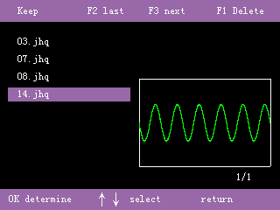
In this interface, you can see the preview of the saved waveform, and at the same time, you can choose to view the waveform with the OK key.
All the data of the waveform will be copied to the oscilloscope, and the oscilloscope can perform arbitrary operations on the waveform.

Parameter Description:

Oscilloscope parameters

Number of channels: 1
Maximum real-time sampling rate: Single channel CH1 200MSa/s
bandwidth: Single channel 50M
Vertical resolution: 8Bit
Vertical gear: 10mV - 5V (Probex1) 100mV - 50V (Probex10)
1,2,5Stepping
impedance: 1MΩ 25pF
coupling: DC, AC
Display mode: Y-T
Input voltage: 40V(Probex1 ) ;400V(Probex10);
Use high-voltage probes, the maximum voltage is determined by the quality of the probe
Time base range: 12.5ns - 5s
100ms - 5s Scan mode(scan)
Storage depth: Per channel 3K
Trigger mode: Automatic, normal and single
Trigger type: Rising edge, falling edge
automatic detection: 50Hz - 20MHz
Cursor measurement: Time, voltage, current, pressure (manual mode)
Can record contrast waveform: 2
Screenshot function: stand by
Self-calibration: stand by
Number of screenshots available 7
Number of waveforms that can be saved 30

Multimeter parameters
Count value 4000 count
DC voltage 0 - 1000V (CAT II area)
AC voltage 0 - 750V (CAT II area)
resistance 0 - 40.00MΩ
capacitance 0 - 100μF (At 100μF, the charging time is more than 30 seconds)
diode 0 - 1.5V
On-off detection Sound when lower than 30Ω

