Instruction manual

Exterior:
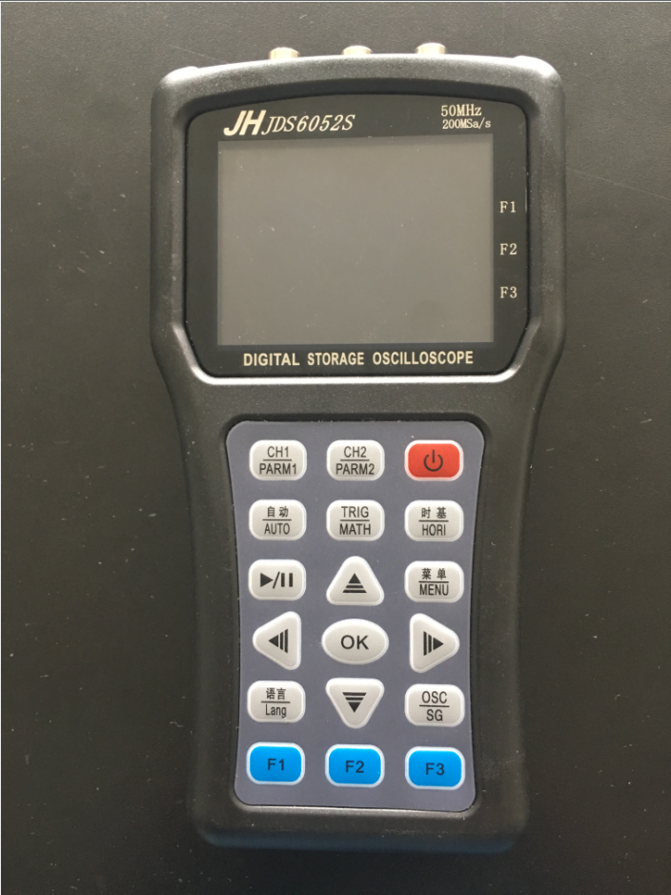

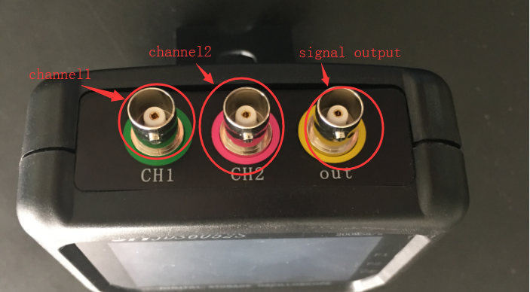

Description of the oscilloscope display interface:
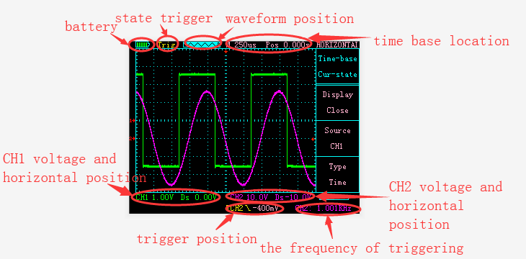

Description of the oscilloscope button:
As shown in the figure below, there are 18 oscilloscope buttons in the product :
CH1/PARM1,CH2/PARM2,TRIG/MATH,时基/HORI,菜单/MENU These buttons are menu selection buttons, Their specific functions are as follows:

Click CH1 / PARM1 to enter the control interface of CH1
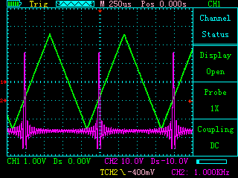
In this interface, the following buttons have the following features:

F1: Control channel 1 is displayed or turned off
F2: Select gear position of probe : x1,x10,x100
F3: Select the coupling mode of channel 1 as DC or AC
↑: Increase the size of the channel 1 unit grid representation (5V-10mV)
↓: Reduce the size of the channel 1 unit grid representation (5V-10mV)
←: Move the channel 1 arrow down
→: Move channel 1 arrow up

Click CH1 / PARM1 again to enter the parameter display interface of CH1
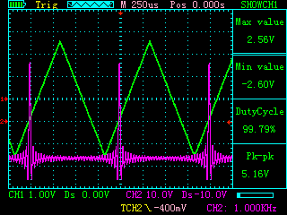
In this interface, the following buttons have the following features:

F1: invalid
F2: invalid
F3: invalid
↑: Increase the size of the channel 1 unit grid representation (5V-10mV)
↓: Reduce the size of the channel 1 unit grid representation (5V-10mV)
←: Move the channel 1 arrow down
→: Move channel 1 arrow up

Description: The displayed parameters have maximum, minimum, duty cycle, peak-to-peak value

Click CH2 / PARM2 to enter the control interface of CH2
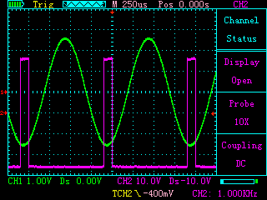
In this interface, the following buttons have the following features:

F1: Control channel 2 is displayed or turned off
F2: Select Increase of probe : x1,x10,x100
F3: Select the coupling mode of channel 1 as DC or AC
↑: Increase the size of the channel 2 unit grid representation (5V-10mV)
↓: Reduce the size of the channel 2 unit grid representation (5V-10mV)
←: Move the channel 2 arrow down
→: Move channel 2 arrow up

Click CH2 / PARM2 again to enter the parameter display interface of CH2
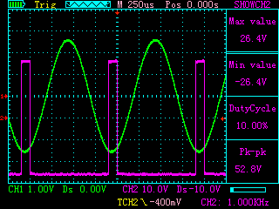
In this interface, the following buttons have the following features:

F1: invalid
F2: invalid
F3: invalid
↑: Increase the size of the channel 2 unit grid representation (5V-10mV)
↓: Reduce the size of the channel 2 unit grid representation (5V-10mV)
←: Move the channel 2 arrow down
→: Move channel 2 arrow up

Description: The displayed parameters have maximum, minimum, duty cycle, peak-to-peak value

Click the “TRIG / MATH” button to enter the trigger control interface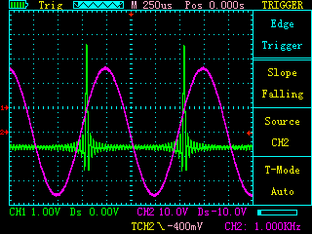
In this interface, the following buttons have the following features:

F1: Control the trigger slope to rise or fall
F2: Select the trigger source as CH1 or CH2
F3: Select the trigger: mode as automatic, normal or single
↑: Invalid
↓: invalid
←: Move the trigger arrow down
→: Move the trigger arrow up

Click the TRIG/MATH button again to enter the MATH interface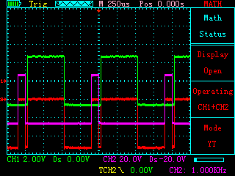
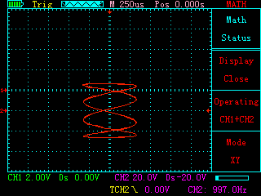
In this interface, the following buttons have the following features:

F1: Whether to display the MATH waveform
F2: Select the function of MATH: CH1+CH2, CH1-CH2 or CH2-CH1
F3: Choose whether the display mode is YT mode or XY mode
↑: invalid
↓: invalid
←: invalid
→: invalid

Click the "时基 / HORI" button to enter the time base control interface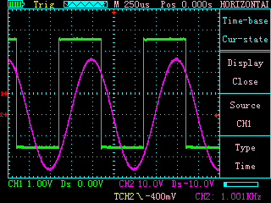
In this interface, the following buttons have the following features:

F1: Whether to display the auxiliary ruler line
F2: Select the calibration target line to be CH1, CH2, Ref-A or Ref-B
F3: Select the type of auxiliary ruler line is time or voltage
↑: Reduce time base (5s - 12.5ns)
↓: Amplify time base (5s - 12.5ns)
←: Move the time base arrow to the left
→: Move the time base arrow to the right

Click the “时基/HORI” button again to enter the ruler line interface.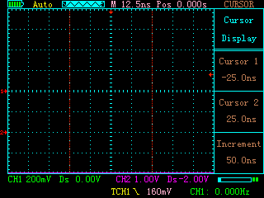
In this interface, the following buttons have the following features:

F1: invalid
F2: invalid
F3: invalid
↑: Ruler 2 moves to the left
↓: Ruler 2 moves to the right
←: Ruler 1 moves to the left
→: Ruler 1 moves to the right

Description: The displayed parameters are the position of the ruler 1, the position of the ruler 2 and the difference increment of their position.
Click the “菜单/MENU” button once to enter the waveform storage interface.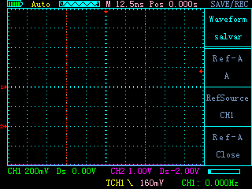
In this interface, the following buttons have the following features:
F1: Select to store the waveform to A or B
F2: Select the stored source as CH1 or CH2
F3: Whether to display the stored waveform
↑: invalid
↓: invalid
←: invalid
→: invalid

Click the “菜单/Menu” button a second time to enter the settings interface.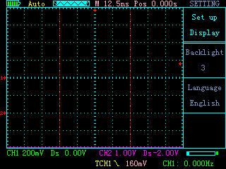
In this interface, the following buttons have the following features:
F1: Select backlight brightness
F2: Select language type
F3: invalid
↑: invalid
↓: invalid
←: invalid
→: invalid

Click the “菜单/MENU” button for the third time to enter the setting interface.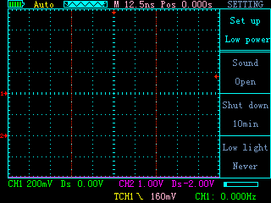
In this interface, the following buttons have the following features:

F1: Control button sound is on
F2: Select the time for automatic shutdown
F3: Select the level of power saving
↑: invalid
↓: invalid
←: invalid
→: invalid

Click the “Menu/Menu” button for the fourth time to enter the settings interface.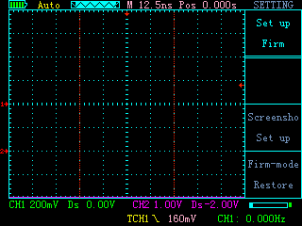
In this interface, the following buttons have the following features:

F1: invalid
F2: Enter the screenshot interface
F3: Restore factory settings
↑: invalid
↓: invalid
←: invalid
→: invalid

Click the “菜单/MENU” button for the fifth time to enter the reverse interface.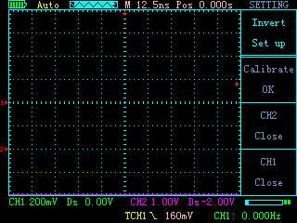
In this interface, the following buttons have the following features:
F1: Oscilloscope self-calibration
F2: Whether CH2 turns on the inversion
F3: Whether CH1 turns on the inversion
↑: invalid
↓: invalid
←: invalid
→: invalid

In the screenshot interface, the button functions are as follows:
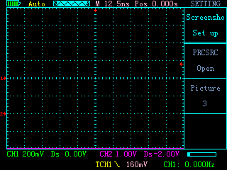
F1: Choose whether to enable the screenshot function
F2: Choose the name of the saved image
F3: invalid
↑: invalid
↓: invalid
←: invalid
→: invalid

Description: When the screenshot function is enabled, pressing the OK button will take a screenshot. When the screenshot function is off, pressing the OK button is the function to save the waveform. In the off state, press the switch button and ok button at the same time, the oscilloscope will enter the U disk mode, connect the computer with the USB cable to view the screenshot in the U disk.

- button:
Power on or off
自动/AUTO button:
Automatic detection of waveforms, detection range is 20MHz - 50Hz.
▶/‖button:
Stop or start waveform display.
语言/Lang:
Switch display language
OSC/SG:
Switch the functions of the oscilloscope and signal generator.

Note: In the off state, press the power button and OK button at the same time. The oscilloscope will enter the U disk mode.

The Description of Signal generator interface:
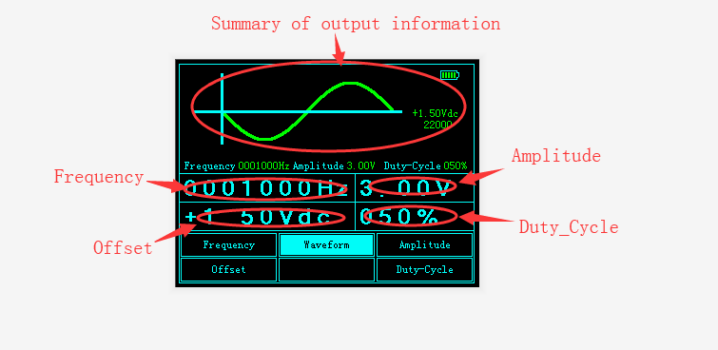

Description of the signal generator button:
F1: Select frequency function or offset function
F2: Select the type of output waveform
F3: Select amplitude function or duty cycle function
↑: Change the number of the output
↓: Change the number of the output
←: Select the number to change
→: Select the number to change

Note: After setting the parameters, you need to confirm the output by pressing OK.

Firmware upgrade instructions:
In the off state of the machine, press and hold the OK button and then press the power button, it will enter the U disk mode, insert usb to connect to the computer, the U disk will appear, first format the U disk, copy the upgrade file update.bin Press the menu / MENU button to upgrade.

Oscilloscope parameters
USB interface ： 1
The number of channels : 2
Maximum real-time sampling rate: Single channel CH1 200MSa/s Dual channel CH1,CH2 100MSa/s
bandwidth: Single channel 50M Dual channel 25M
Vertical resolution: 8 bits
Vertical gear: 10mV - 5V (probe x1) 100mV - 50V ( probe x10)
1,2,5 Stepping level
impedance: 1MΩ 25pF
coupling: Dc,Ac
Display mode: Y-T / X-Y
Input voltage: 40V(probe x1 ) ;400V(probe x10);
Using a high voltage probe, the maximum voltage is determined by the quality of the probe
Time base range: 12.5ns - 5s
100ms - 5s Scan mode (scan)
Storage depth: Per channel 3K
Trigger mode: automatic, normal and single
Trigger type: Rising edge, Falling edge
automatic detection: 50Hz - 20MHz
Cursor measurement: Time, voltage (manual mode)
Recordable contrast waveform: 2
Screenshot function: stand by
Mathematical calculation: CH1+CH2,CH1-CH2,CH2-CH1
Self-calibration: stand by

Signal generator
The number of channels: 1
frequency: Sine wave (1Hz-5MHz)
Square wave (1Hz-1MHz)
Positive sawtooth wave (1Hz-1MHz)
Reverse sawtooth (1Hz-1MHz)
Amplitude: 100mV - 8V
Offset: maximum +-(0V-4V)
Duty cycle: 0% - 100%

